
2024 KANSAS STATE DEPARTMENT OF EDUCATION ANNUAL CONFERENCE
STUDENT ART CONTEST
Great Ideas in Education: Lighting the Path Forward!

Purpose
To encourage students to use their creativity by entering an illustration (art conveying a visual representation of a theme or idea) for the Kansas State Department of Education (KSDE) Annual Conference theme, Great Ideas in Education: LIGHTING THE PATH FORWARD

Eligibility
This contest is open to Kansas K-12 public and private school students. Each contest entry must include the student’s name and the student’s classroom teacher’s information.

Entries must be postmarked by
May 24,
2024
For more information, contact:
Pat Bone Senior Administrative Specialist
Division of Learning Services
pbone@ksde.org (785) 296-2303
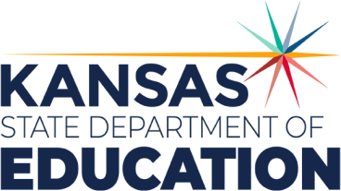

Judging and Awards
One winner will be selected in each of the following grade level divisions:
Guidelines
- All illustrations must be based upon the conference theme, Great
Ideas in Education: Lighting the Path Forward
- No artwork larger than letter-size paper (8.5 inches
by 11 inches).
- Art without words is preferred.
- There are no limitations on the use and number of colors.
- Acceptable media for illustrations are crayons, pencils, photos, paints, markers and computer prints.
- Do not send collage illustrations.
- The entry form (see attached) must be completed and included with the drawing or
graphic.

 Grades K-4
 Grades 5-8
 Grades 9-12
From the three grade-level winners, a first-place, second-place and third-place winner will be selected and prizes will be awarded as follows:
 Third Place: $75
 Second Place $100
 First Place $150
The first-place illustration will be featured in the conference materials. The three winning illustrations will be displayed at the conference and will be published on the KSDE website (https://www.ksde.org/).
All winners will be recognized during the Annual Conference.
The winner’s sponsoring teachers will receive a nontransferable complimentary conference registration.
Contest winners, their sponsoring teacher and principal will receive notification of contest results.
All products submitted become the property of KSDE and may be distributed freely. Decisions are at the discretion of the judges.
Note: Entries will not be returned.

Kansas leads the world in the success of each student.

2 0 2 4 KANSAS STATE DEPARTMENT OF EDUCATION ANNUAL CONFERENCE

STUDENT ART CONTEST
Great Ideas in Education: Light the Path Forward!
Entry Form
Student name:

Age: Grade:

School:

School address:

City:
State
Zip:

Teacher name:

Teacher email:

Principal name:

Principal email:

District Administrator/Superintendent name:

All entries are to be mailed with this form to: Kansas State Department of Education Attention: Pat Bone
900 SW Jackson Street, Suite 656
Topeka, Kansas 66612-1212

Entries must be postmarked by May 24, 2024.

For more information, contact:
Pat Bone
Senior Administrative Specialist Division of Learning Services (785) 296-2303
pbone@ksde.org

Kansas State Department of Education 900 S.W. Jackson Street, Suite 656
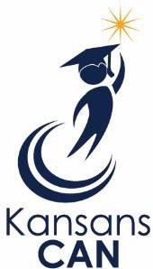
Topeka, Kansas 66612-1212
(785) 296-3201
www.ksde.org

